ServiceBridge Public API integration with PowerBI

# Overview

The procedure of auto data refresh consists of the following steps:

* Step 1. Get data on your always-on server from ServiceBridge Public API.
* Step 2. Schedule periodic ServiceBridge Public API data refresh on your always-on server.
* Step 3. Build Power BI dashboards based on JSON data you have in the C:\PowerBI\ folder.
* Step 4. Install and configure Power BI Data Gateway (<https://powerbi.microsoft.com/en-us/gateway/>) to the always-on server.
* Step 5. Setup auto-refresh on PowerBI Web.

# Step 1 – Get Data

* Copy all files to C drive (C:\PowerBI).
* “C:\PowerBI\Demo Report.pbix” uses data sources, which are located in:
  + C:\PowerBI\SB\Demo Report_Report.json
* The data source is refreshed when “C:\PowerBI\refresh.bat” is executed. If you want to automate data source file refresh, then schedule “C:\PowerBI\refresh.bat” in Windows Task Scheduler (Step 2).
* Default configuration for data source refresh is:
  + Retrieve data from “Demo Report” report
  + Retrieve data for the last 12 months (current date minus 12 months)
  + Authorize to ServiceBridge using Public API user “demo_api_user”:

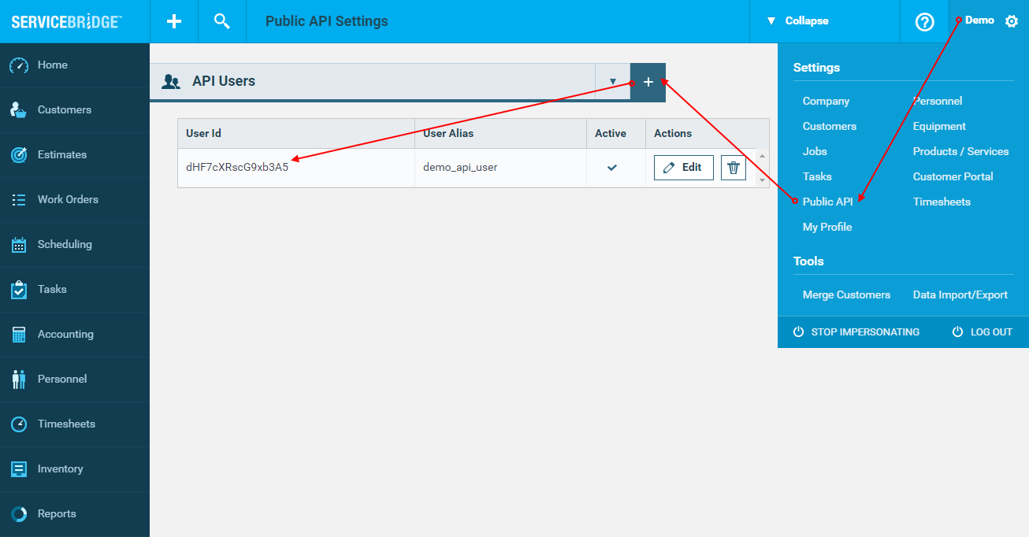

If you want to change default configuration, then you need to edit “C:\PowerBI\SB\Download Report.js” file:

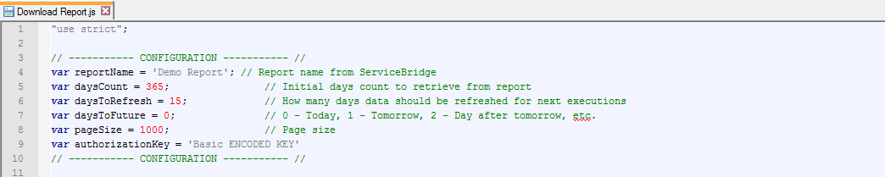

Authorization key hash is base64 encoded string. If you want to change a user, you need to encode string (UserId:Password), e.g. demo_api_user:SecretPassword. The string can be encoded online, e.g.: <https://www.base64encode.org/>

# Step 2 – Schedule periodic job

Schedule periodic job to refresh data on necessary periodicity. We recommend to schedule it no more frequently than every half hour, because data refresh takes some time to retrieve data for 12 months period.

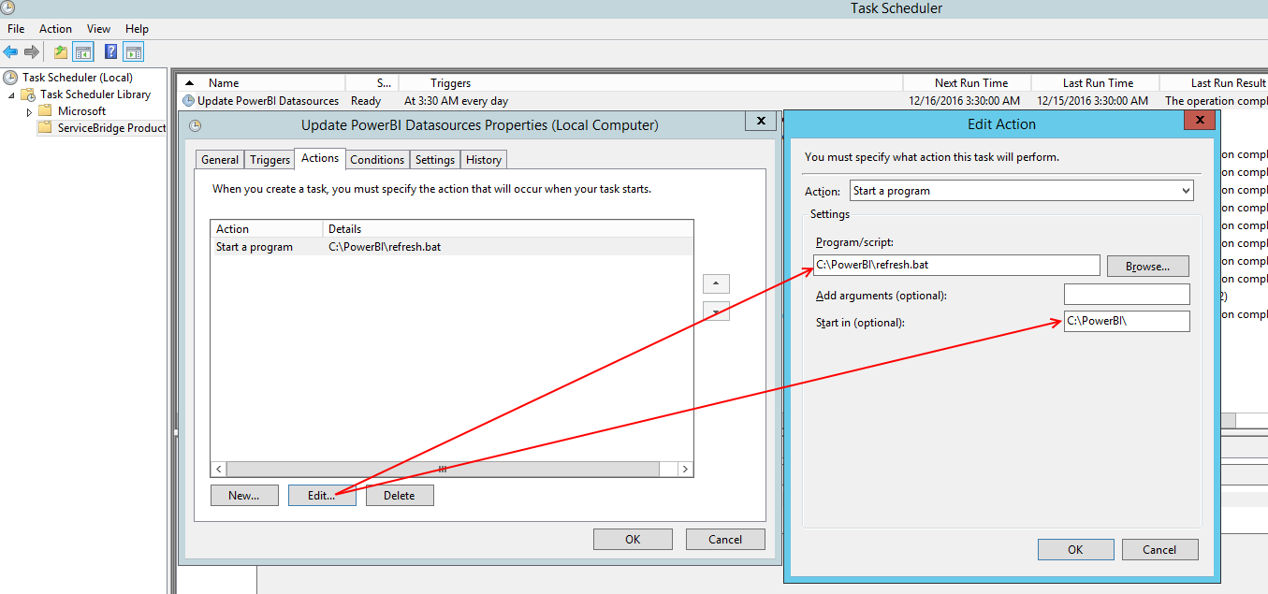

# Step 3. Build PowerBI dashboards

“Demo Report.pbix” already has connected data sources and sample dashboards.

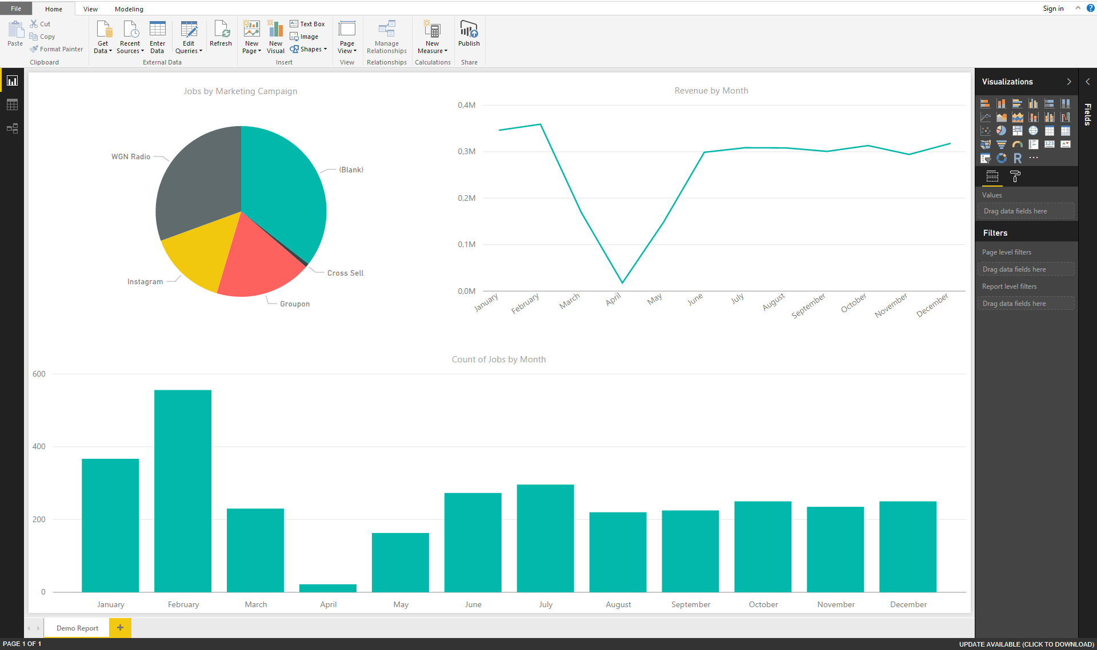

There is 1 data sources:

* **Report** – it’s the actual data retrieved from Public API (ServiceBridge report)

# Step 4. Install and configure PowerBI Data Gateway

To install On-premises data gateway use instructions from the <https://powerbi.microsoft.com/en-us/documentation/powerbi-gateway-onprem/> article.

Once the gateway is configured, you will be able to make use of it to connect to on-premises data sources on PoweBI Web (<https://app.powerbi.com>). First you will need to add your data sources to the gateway within the Power BI service. This is done within the Manage gateways area: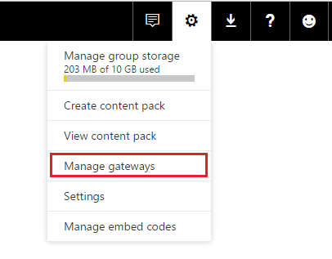

You can refer to the manage data sources articles for more information: <https://powerbi.microsoft.com/en-us/documentation/powerbi-gateway-enterprise-manage-sql/>

You need to add the Folder data source to access the C:\PowerBI\ folder on the server.

# Step 5. Setup scheduled auto-refresh on PowerBI Web

After you have updated PowerBI reports using JSON data sources from the C:\PowerBI folder, you are ready to setup a scheduled auto-refresh for the report. This is done via:

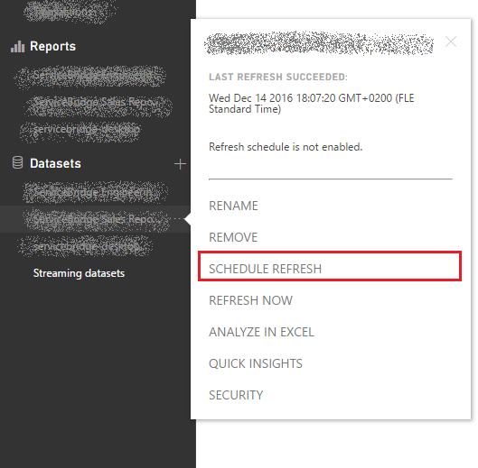

Make sure that you connected data gateway is selected:

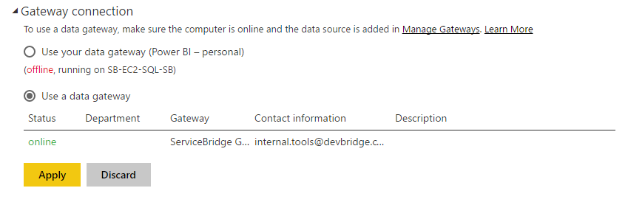

Now just select times when data should be refreshed from the server.

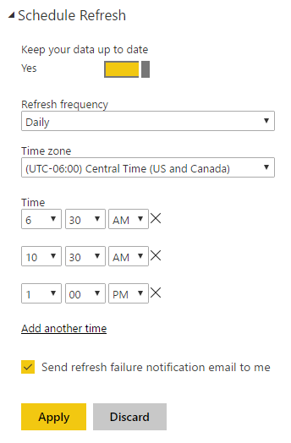

Detailed official instructions <https://powerbi.microsoft.com/en-us/documentation/powerbi-refresh-scheduled-refresh/>